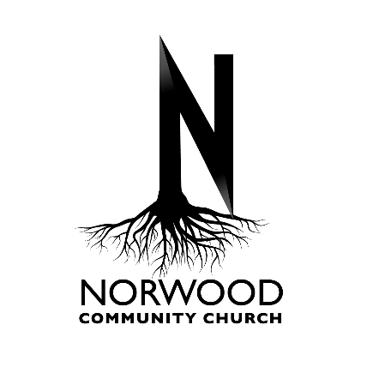
Outing Release Form (CHILD)

I give permission for my child _____________________________________________ to participate the Norwood Church Fishing Trip April 5, 2025. The event will be held at Sisters Creek Marina (8203 Hecksher Drive, Jacksonville, FL 32226). The projected time of departure from NCC is 7:30 am. The expected time of return is 3:00 pm.

By participating I agree to release and discharge, Norwood Community Church (Mount Horeb Baptist Church, Inc.) its employees and volunteers exercising reasonable care within their scope of employment, from any and all liability, claims, damages, suits, judgments, and settlements involving personal injury and property damage resulting from or arising in connection with the aforementioned activities and while in transit to and from said activity.

Please list any Allergies (including food) or Medical Needs that you may have that the Staff needs to be made aware of.

Date:_________________ 2025

______________________________
Print Name (of Parent)

______________________________
Signature (of Parent)

______________________________
Emergency Contact (Name & Ph Number)

____________________________________________
Witness (Printed Name & Signature)

Outing Release Form (ADULT)

I ______________________________________________ am participating in the Norwood Church Fishing Trip April 5, 2025. The event will be held at Sisters Creek Marina (8203 Hecksher Drive, Jacksonville, FL 32226). The projected time of departure from NCC is 7:30 am. The expected time of return is 3:00 pm.

By participating I agree to release and discharge, Norwood Community Church (Mount Horeb Baptist Church, Inc.) its employees and volunteers exercising reasonable care within their scope of employment, from any and all liability, claims, damages, suits, judgments, and settlements involving personal injury and property damage resulting from or arising in connection with the aforementioned activities and while in transit to and from said activity.

Please list any Allergies (including food) or Medical Needs that you may have that the Staff needs to be made aware of.

Date:_________________ 2025

______________________________
(Print Name)

______________________________
Signature

______________________________
Emergency Contact (Name & Ph Number)

____________________________________________
Witness (Printed Name & Signature)

